Heart of Worship / 찬양의 열기 / El Corazon de Alabanza

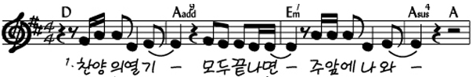
When the music away and I simply
fades, and all is stripped come
Cuando no hay canción y todo se acabó vengo ante ti
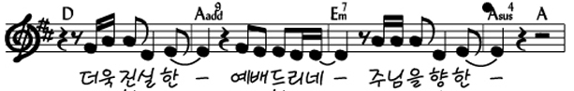
Longing just to worth that will bless your
bring something that's of heart
solo a ofrecer algo de valor a tu corazón

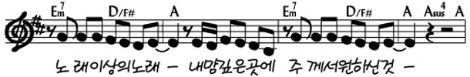
I'll bring You song, for a song in You have
more than a itself is not what required
Traeré canción tu deseo es simple canción
más que una más que una
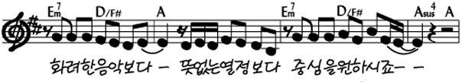
You search much within through the into my heart
deeper ways things appear, You're looking
escudriñas más allá tu ves el
de lo que se ve corazón

Used by Permission. CCLI #11103902
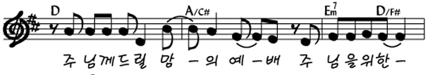
I'm coming back to the all about You
heart of worship and it's
Regresaré a adorar como antes, donde todo eres tu
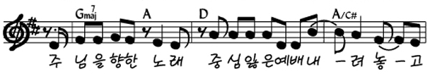
All about You, Jesus; I'm sorry Lord for the
thing I've made it
todo eres tu Jesus; Perdoname por
haber cambiado
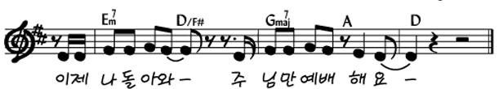
When it's all about You, it's all about You Jesus
Todo eres tú, todo eres tú Jesus
*Improv: D A Em7 (D/F#) G A (Repeat)

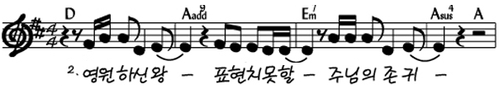
King of endless worth, how much You deserve
no one could express
Digno eterno rey expresar nunca tú
podré lo que mereces
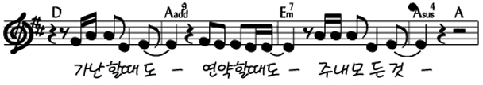
Though I'm weak and Yours, every single breath
poor, all I have is
aunque debil soy y pobre también mi aliento eres tú
Used by Permission. CCLI #11103902

